**Oppgave_1 and 2**

I installed the MySQL shell and MySQL Workbench. Then I made schemas, given name is Oblig_1.

And I download the videogame_small.csv to import the data. Then I import the data from Table Data Import Wizard. Again, I modify the data to have at list INT, VARCHAR () FROM Alter Table. I also created a column named “id” to uniquely identify each row.So now in my data have the new is “id” which is not null (NT) and automatic increase (AI).

**2,**

**full data**

a) Here I am selecting everything from the Table videogame_small.

**SELECT** * **FROM** oblig_1.videogame_small;

b) Here iam selecting the title, platform and release_date from the Table, where platform is “pc” order by release_date DESC.

**SELECT** title, platform, release_date

**FROM** oblig_1.videogame_small

**WHERE** platform = "pc"

**ORDER** **BY** release_date **DESC**;

c)Here I am selecting the title, platform, release_date from the Table and order by release_date desc.

**SELECT** title, platform, release_date **FROM** oblig_1.videogame_small

**ORDER** **BY** release_date **DESC**;

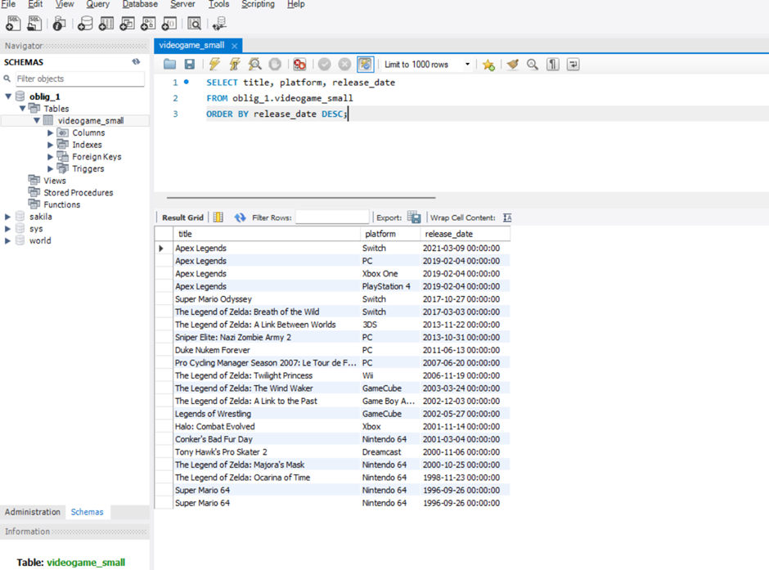

d)Here iam selecting the genre, count(title) as amount_of_games from the Table and group by genre.

**SELECT** genre, **count**(title) **as** amount_of_games **FROM** oblig_1. videogame_small

**ORDER** **BY** genre;

Here I am going to retrieve the amount of games per genre

e) Here iam selecting everything from the Table where userscore is null.

**SELECT** \***FROM** oblig_1. videogame_small

**WHERE** userscore **IS** **NULL**;

